**Amazon customers Dashboard**

Wireframe Documentation

Amazon Customer DashBoard

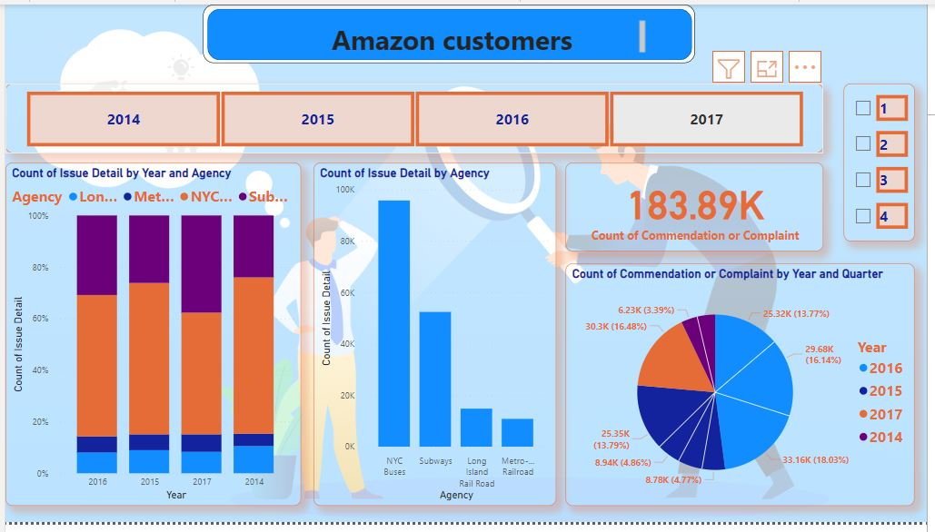

Amazon customer Dashboard

This is a customer Dashboard

In this dashboard we have calculated

1. Count of issues by year
2. Count of issues Details
3. Count of commendation or complain

3.Count of commendation or complain

1. Count of issues Details
2. Count of issues by year